

**CMPE 280**

**Web and UI design**

**Bootstrap and jQuery Website Development**

**Date: 04/30/2016**

**Term: Spring 2016**

**Team Coéquipiers**

**Gayatri Priyadarshani Rath (010044164)**

**Harshita Ganduri (008672508)**

**Khushbu Sheth (SID: 010004033)**

**Sai Manasa Sudha Jonnalagadda (010032555)**

**Descriptions**

**Location and contact us details.**

This page will give information about the company’s locations. All the locations are also marked on the map. On click of the location marker address information will appear.

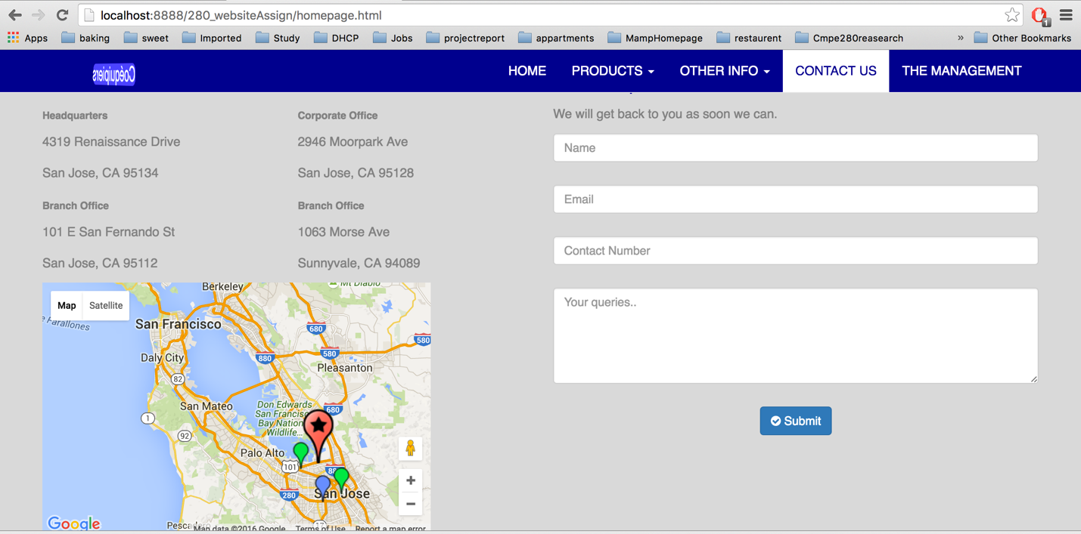

*Contact Us Page*

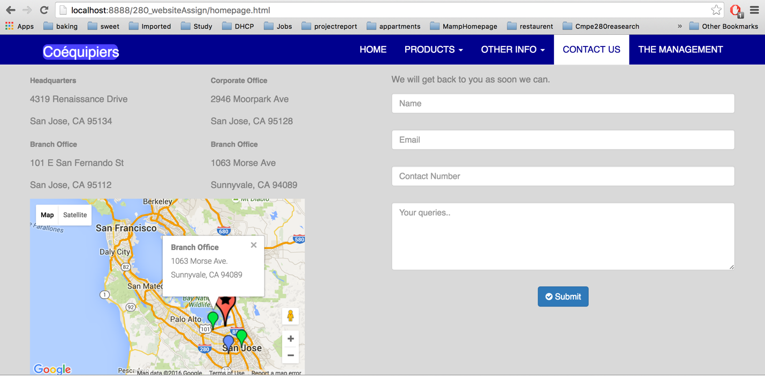

*Address information about the location on click of the marker*

This page also allows users to send feedback about the website after filling their contact information. Their comments will be saved in the database. After the feedback is saved in the database success message will be displayed.

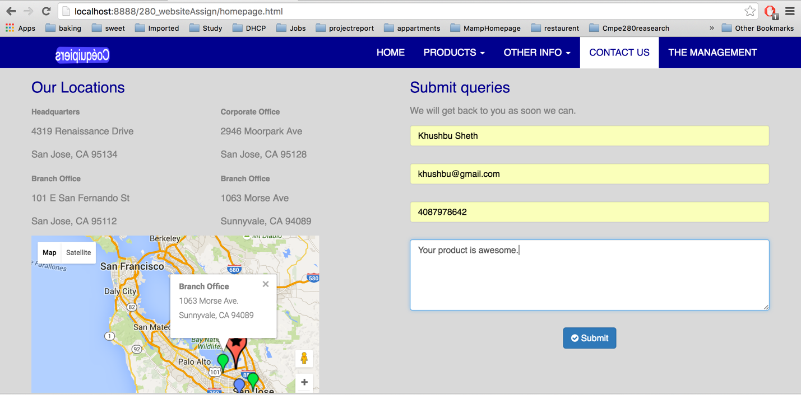

*User submitting the feedback about the company*

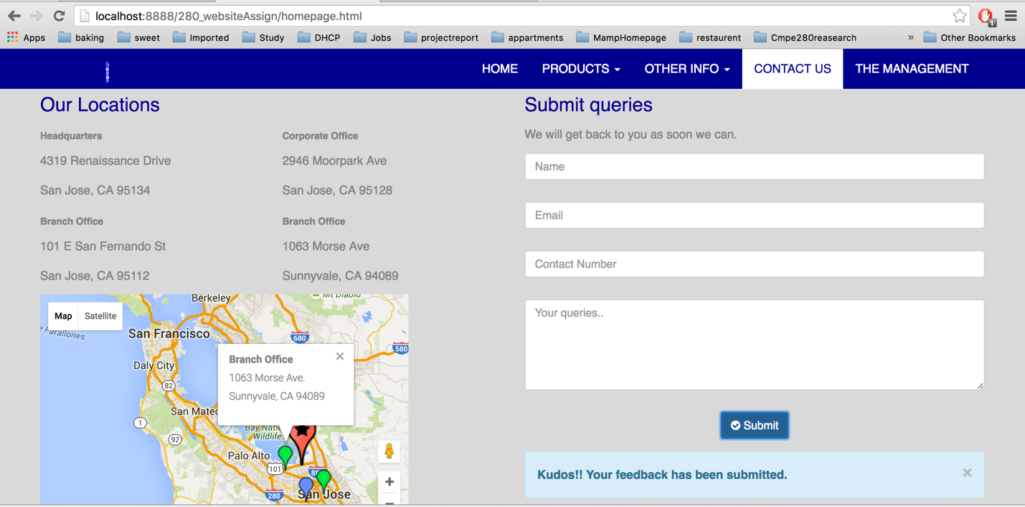

*Success alert after feedback has been submitted*

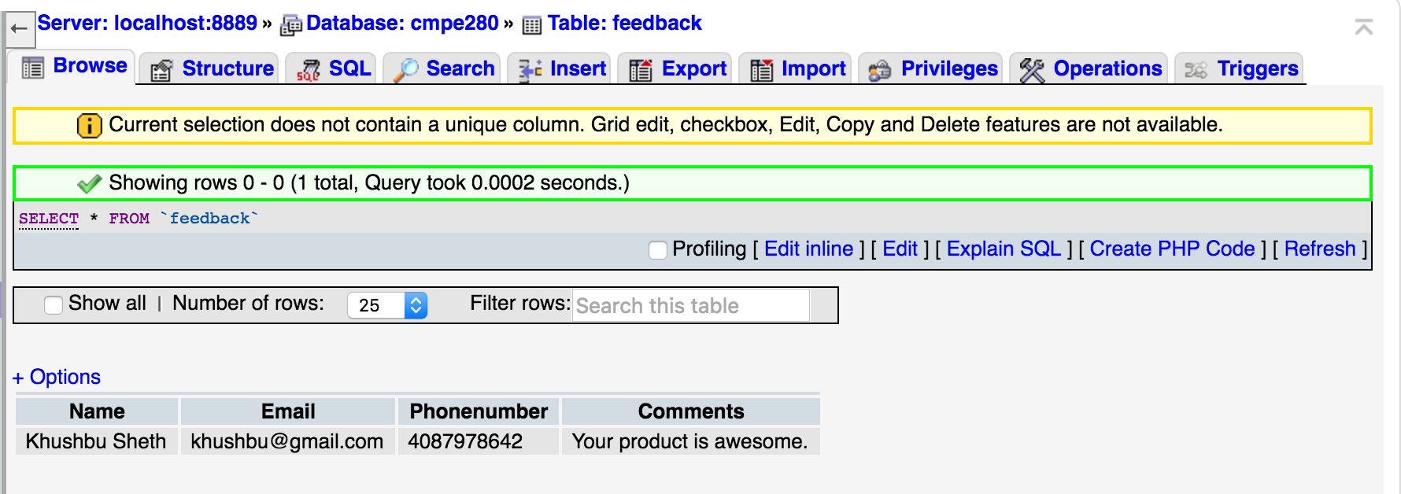

*Feedback details stored in the database*

**Products**

1. **Mobile:**

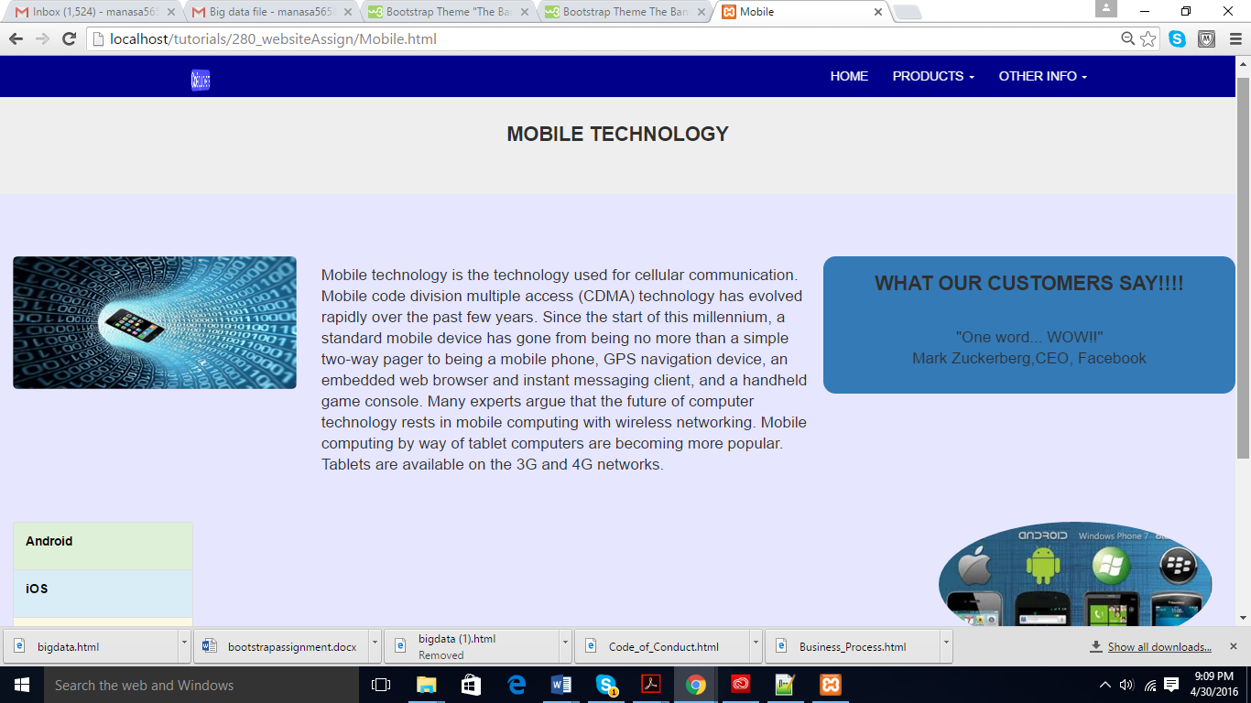

*Mobile Technology page*

This page consists of a description of the mobile technology and also has few lines about various mobile operating systems. This page mainly consists of four parts:

* Static mobile image
* Description para of mobile technologies.
* Customer feedback carousel
* List view of various mobile operating systems.

The list view is dynamic, and on lick of each list item the corresponding description of the item appears as follows:

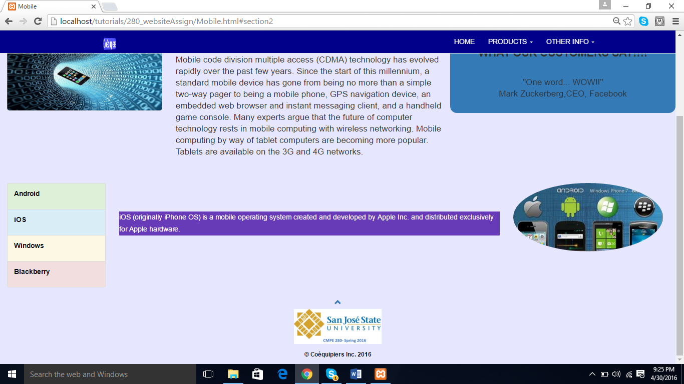

*Mobile Technology page: clicking on list item*

1. **Bigdata**

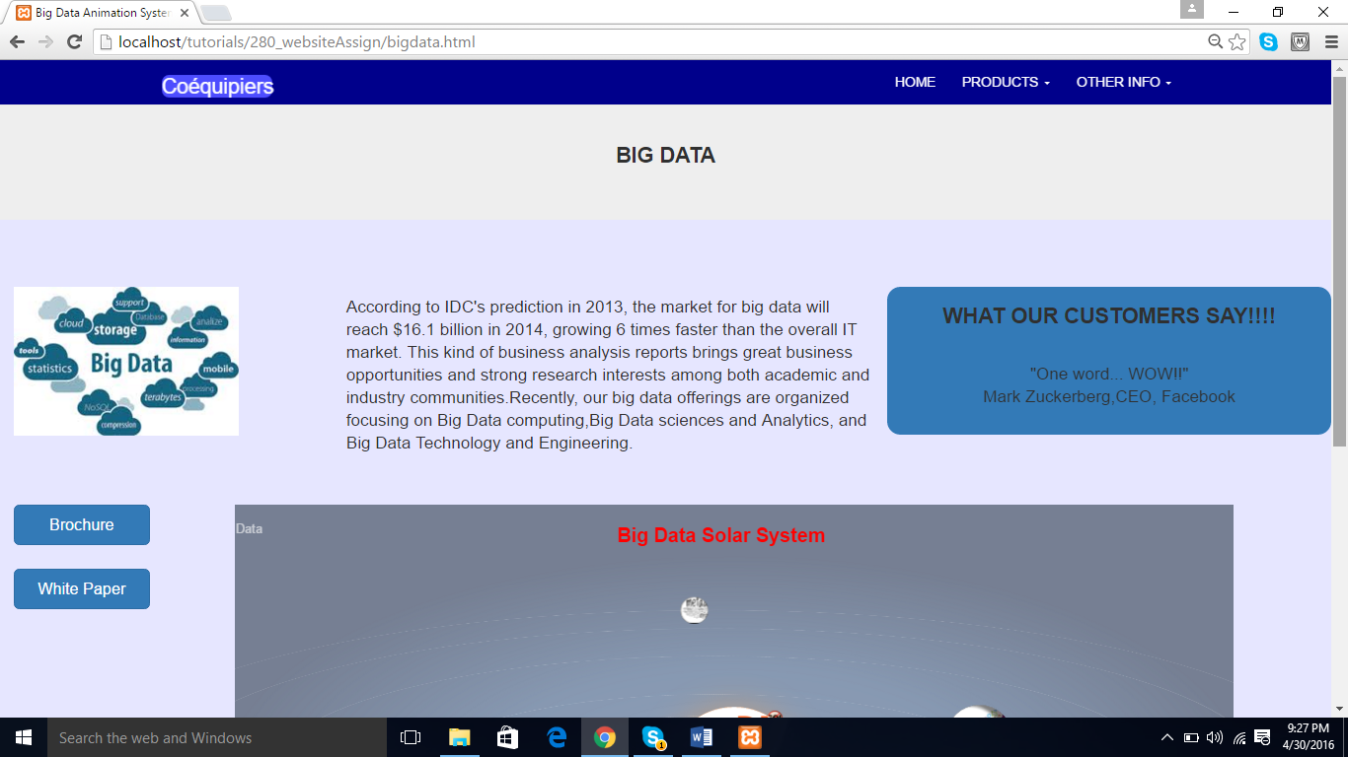

*Big data page*

The big data page has a similar layout as the mobile page, but has two additional items:

Brochure and whitepaper buttons.

Animation.

The animation has been delivered by using the concept of “keyframes”. The animation is rendered as follows:

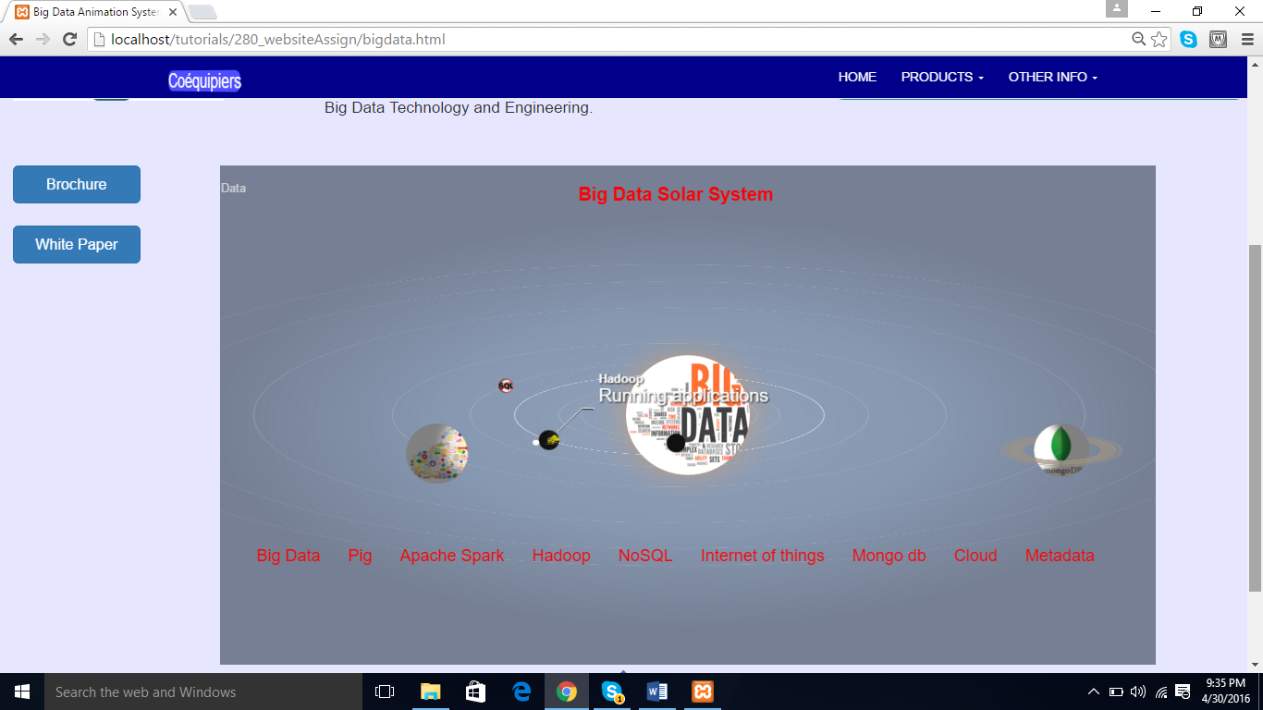

*Big data page -animations*

1. **iot**

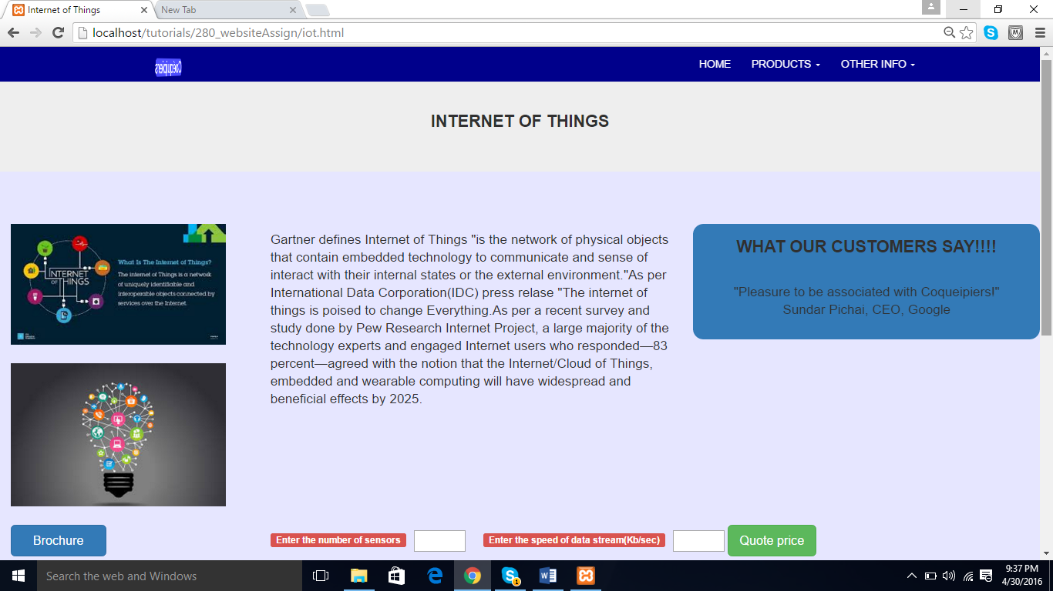

*Internet of Things*

The internet of things page includes a speed gauge high chart that is used to calculate the price of the commodity based on number of sensors and speed of the data stream. The user needs to enter the sensors and data stream speed in the text boxes and on clicking the “quote price” button, the price is calculated and displayed in the speed gauge.

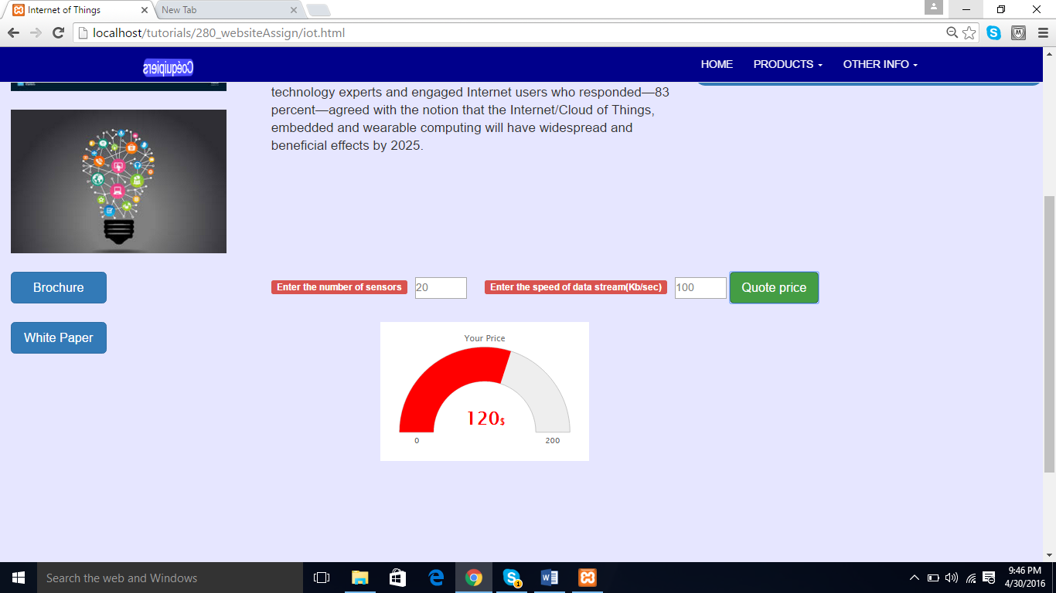

*Internet of Things: Speed Gauge*

In addition to the speed gauge, the white paper and brochure buttons are present which have specific functionality as defined below:

**White paper and brochure download**

On click of whiter paper and brochure button model box will appear. User have to fill out the details like his first name, last name and email-id. After submitting the information, it will be stored in the database and user will be allowed to download the whitepaper and brochure. If user clicks on the reset button, form details will be cleared. If user keeps any field empty, warning message will appear and he will be not allowed to download file.

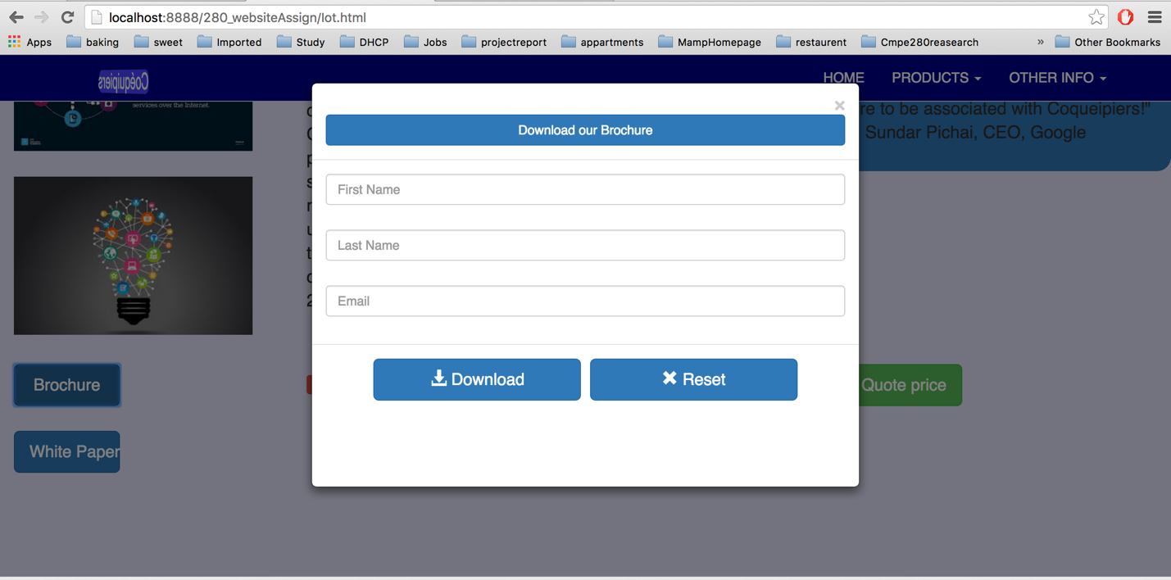

*Download our brochure model box*

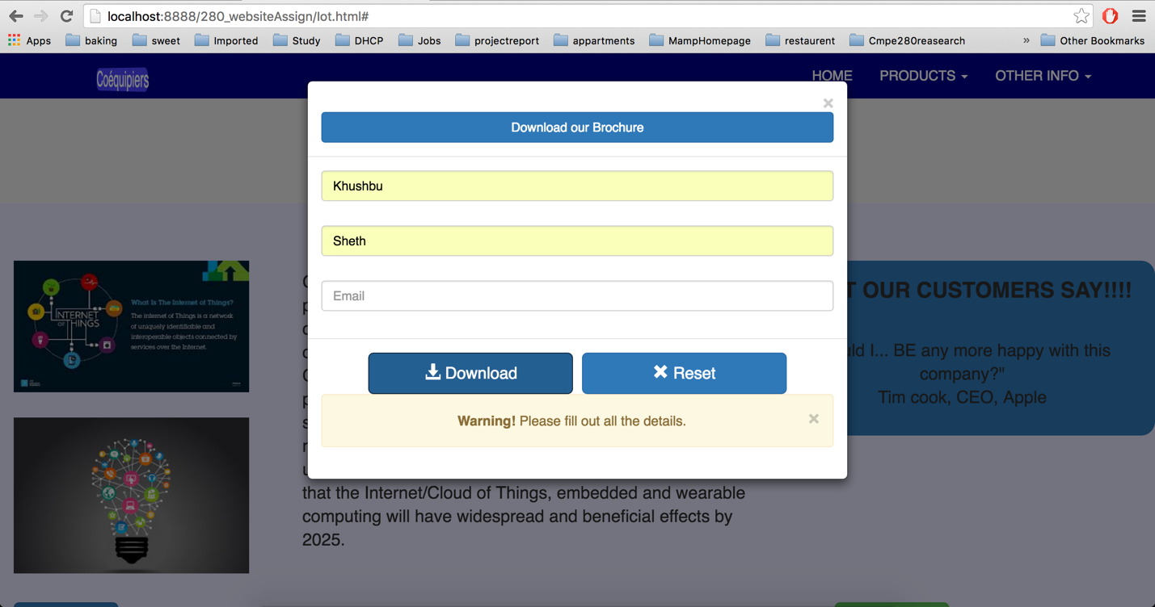

*Warning user about empty fields*

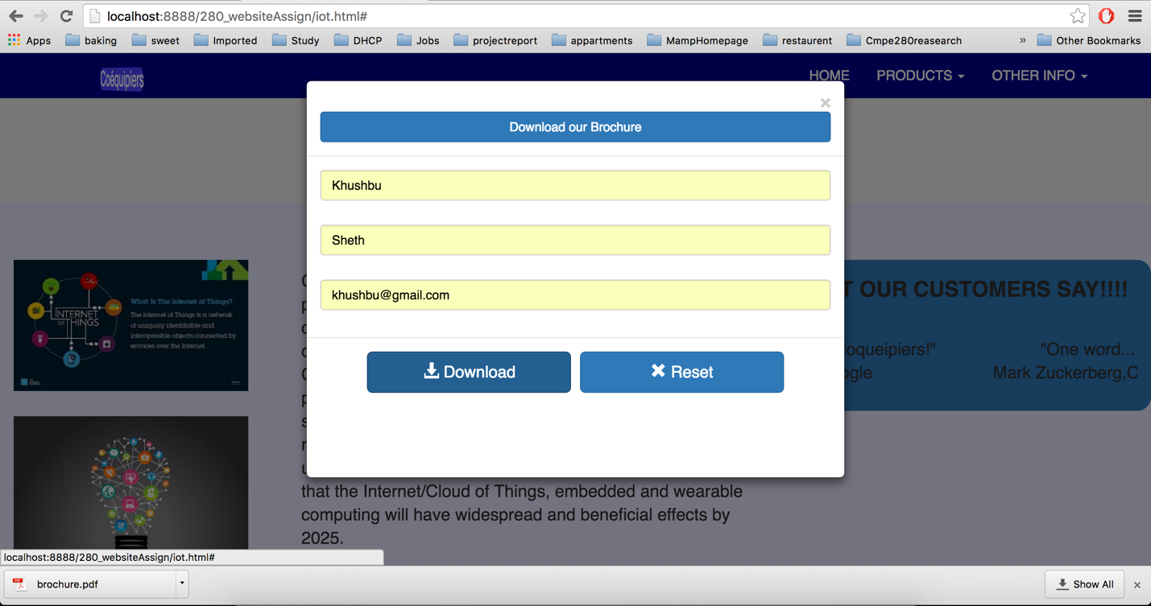

*Broacher is successfully downloaded*

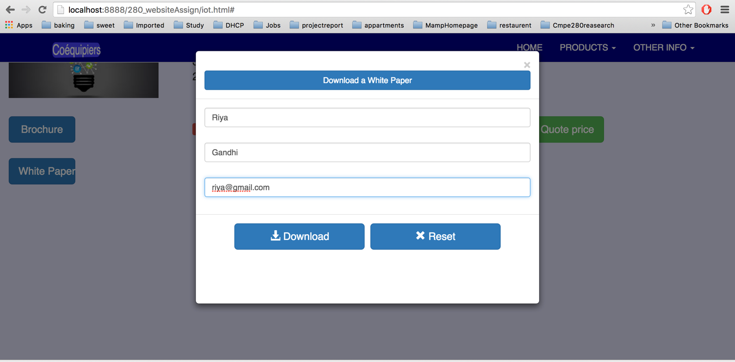

*Download a white paper model box*

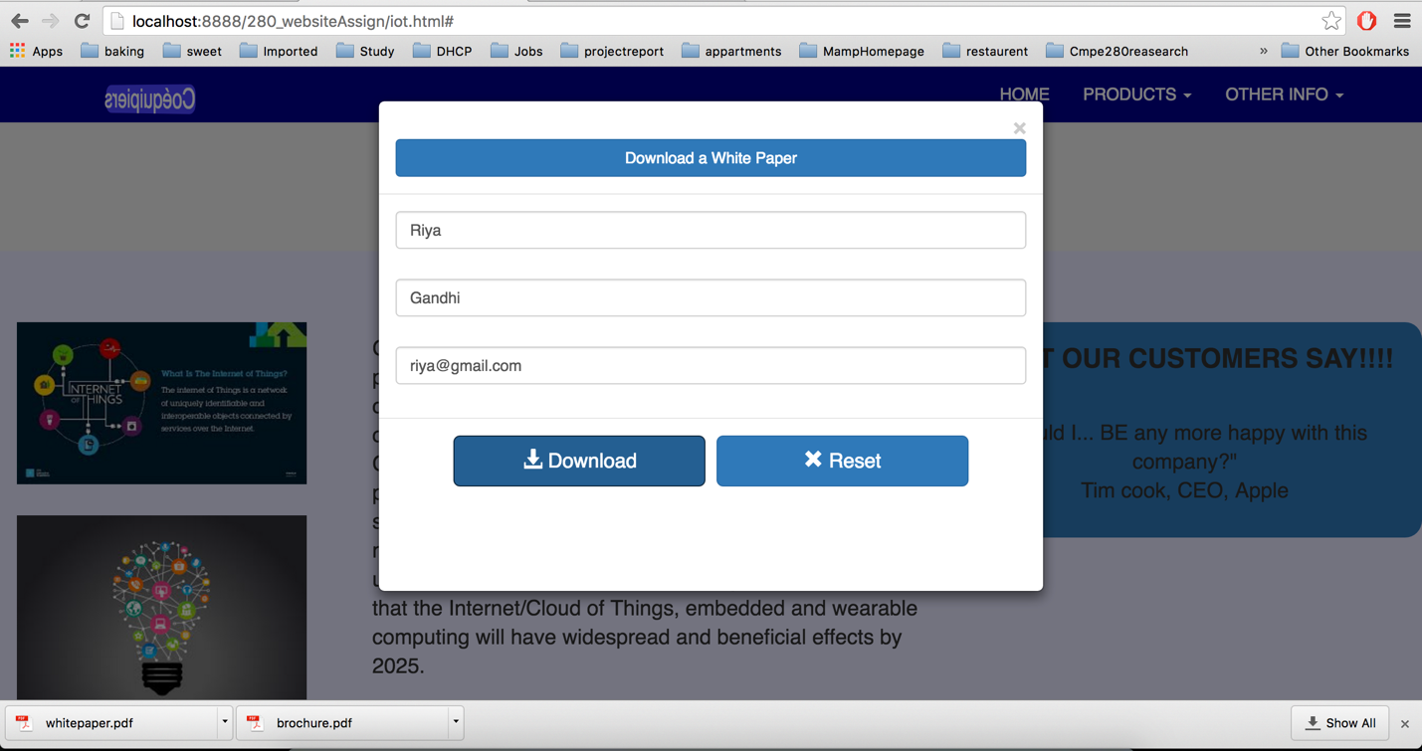

*white paper is downloaded in the download folder*

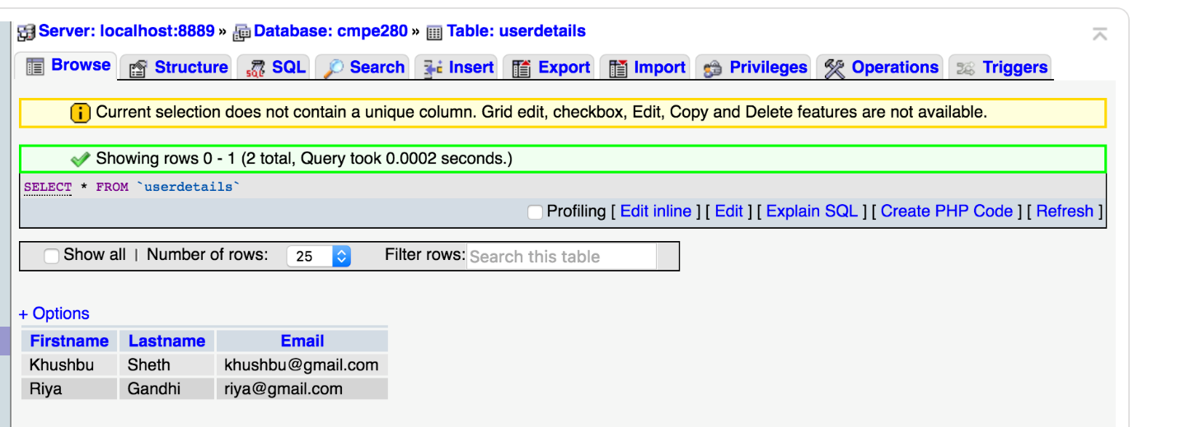

*User details saved in the database*

**Code of conduct page**

This page displays company’s code of conduct policy. When user click on the any code of conduct policy that description for that policy will appear.

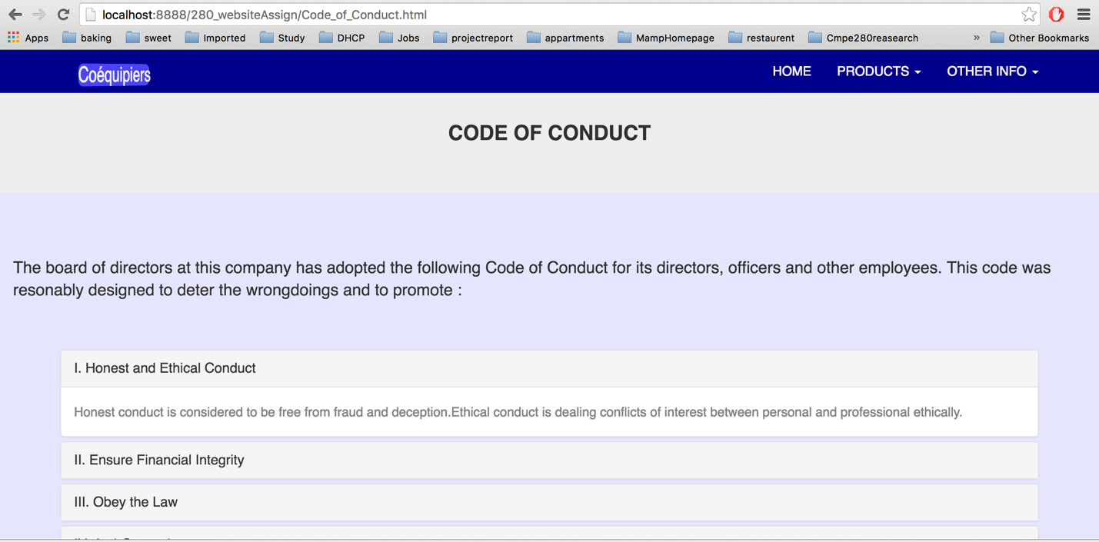

*Code of conduct page*

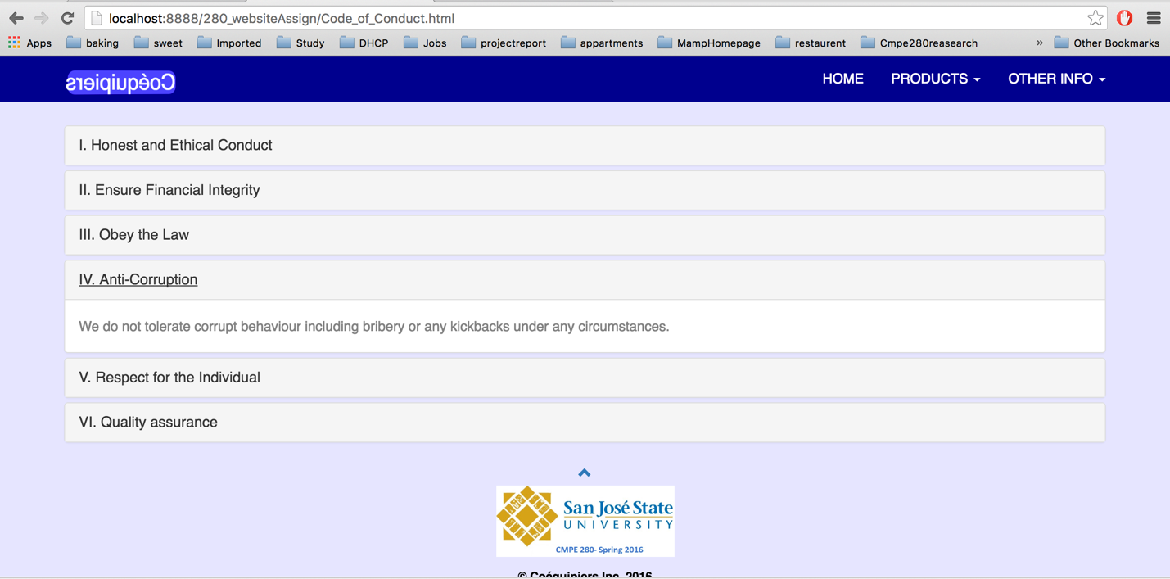

*On click of roman digit code of conduct will get expanded*

**Business process page**

This page describes the business process model for the company in the form of Sankey diagram and flow chart. The 3 level Sankey diagram displays the flow between the different big data components. Flow chart displays overall flow of the big data system.

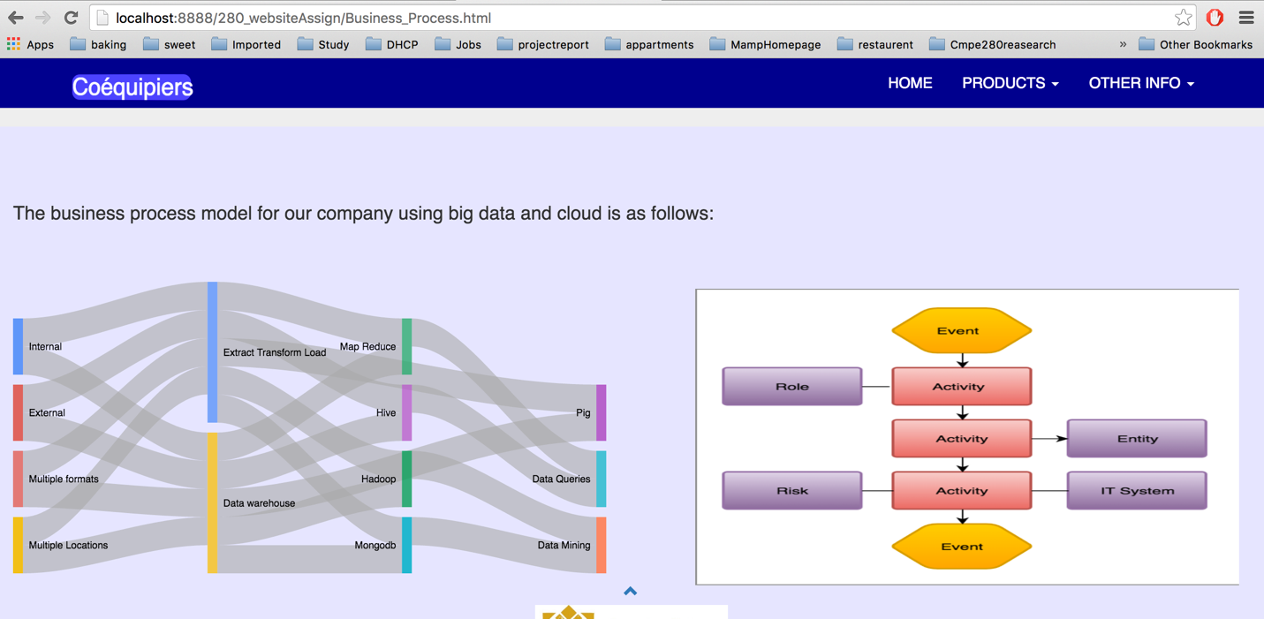

*Business process page*